Adnan Ayub – Ian Scully – Johnathan Flanagan

NCI  Team Project

SOFTWARE APPLICATION

**Contents**

**UML 1** 2

**Use Case Description 1** 3

**UML 2** 5

**Use Case Description 2** 6

# **UML 1**

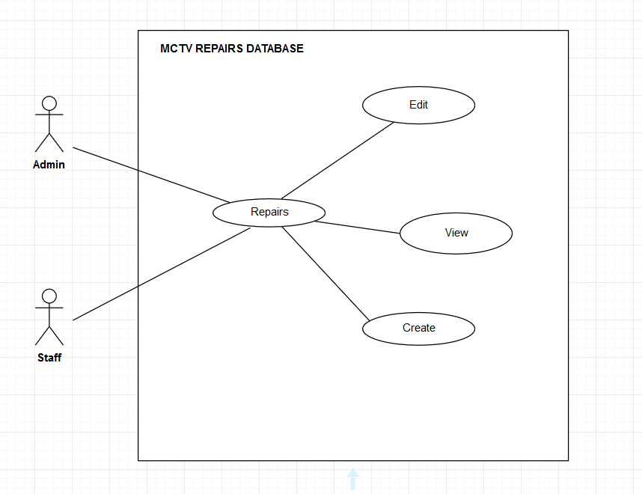

Figure

# **Use Case Description 1**

|  |  |
| --- | --- |
| **Use Case Element** | **Description** |
| **Use Case No** | 1 |
| **Application** | MCTV |
| **Use Case Name** | Repairs |
| **Use Case Description** | A user starts the application and prompted to go to repairs to enter details. |
| **Primary Actor** | Staff |
| **Trigger** | The staff user taps the repair button. |
| **Basic Flow** | 1. The user case starts when staff launches the application and opt repair to enter details. 2. The user input their details in the text fields. 3. The application shows the user that details has been created. |
| **Alternate Flow** | 1. The user does not want to create the data and choose to exit from the application. 2. The user input wrong data in text fields and the system will not accept it. |
| **Termination** | The flow is terminated once the user successfully entered the details and stored in database. |
| **Post Condition** | The user return to the home page and system enters at the waiting state. |

**Use Case**

Repairs in MCTV.

**Scope**

The scope of this use case is for staff to enter the details of repairs in the form.

**Description**

The use case will show the details of repairs.

**Flow description**

Pre-Condition: - The application is for staff

Activation: - The use case starts when the staff goes into repairs form.

Main Flow: -

1. The staff browses the repairs.
2. User can select from three options create, edit and view.
3. The system will provide the data can be edit.
4. The system will provide the text fields for full details to enter.
5. The system will show the data entered and stored it in application database.

Alternate Flow: -

1. The system will not accept the wrong data in the text fields.
2. The system tracks all the details of staff.

Exceptional Flow: -

There is no exceptional flow on this use case.

**Termination: -**

The system stores all the details.

**Post Conditions: -**

The user returns to the main page and the system enters at the wait state.

# **UML 2**

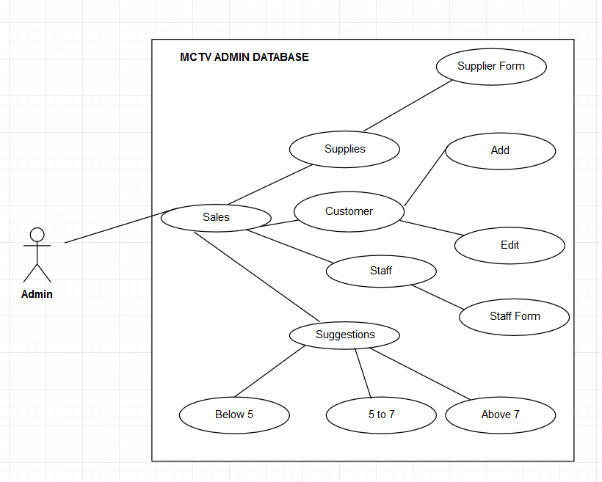

Figure 2

# **Use Case Description 2**

|  |  |
| --- | --- |
| **Use Case Element** | **Description** |
| **Use Case No** | 1 |
| **Application** | MCTV |
| **Use Case Name** | Staff |
| **Use Case Description** | A user starts the application and prompted to go to staff form to enter details. |
| **Primary Actor** | Admin |
| **Trigger** | The admin user taps the staff button. |
| **Basic Flow** | 1. The user case starts when admin launches the application and opt staff to create staff form. 2. The user input their details in the text fields. 3. The application shows the user that details has been created. |
| **Alternate Flow** | 1. The user does not want to create the data and choose to exit from the application. 2. The user input wrong data in text fields and the system will not accept it. |
| **Termination** | The flow is terminated once the user successfully entered the details and stored in database. |
| **Post Condition** | The user return to the home page and system enters at the waiting state. |

**Use Case**

Staff in MCTV.

**Scope**

The scope of this use case is for admin to enter the details of staff in staff form.

**Description**

The use case will show the details of staff

**Flow description**

Pre-Condition: - The application is for admin

Activation: - The use case starts when the admin goes into staff form.

Main Flow: -

1. The admin browses the staff.
2. User can select from three options create, edit and view.
3. The system will provide the data can be edit.
4. The system will provide the text fields for full details to enter.
5. The system will show the data entered and stored it in application database.

Alternate Flow: -

1. The system will not accept the wrong data in the text fields.
2. The system tracks all the details of staff.

Exceptional Flow: -

There is no exceptional flow on this use case.

**Termination: -**

The system stores all the details.

**Post Conditions: -**

The user returns to the main page and the system enters at the wait state.